**Web Tables**

**Web Table in Selenium**

There are two types of HTML tables published on the web-

1. **Static tables**: Data is static i.e. Number of rows and columns are fixed.
2. **Dynamic tables**: Data is dynamic i.e. Number of rows and columns are NOT fixed.

## Selenium

Below is an example of a dynamic web table in Selenium for Sales. Based on input date filters, number of rows will get altered. So, it is dynamic in nature.

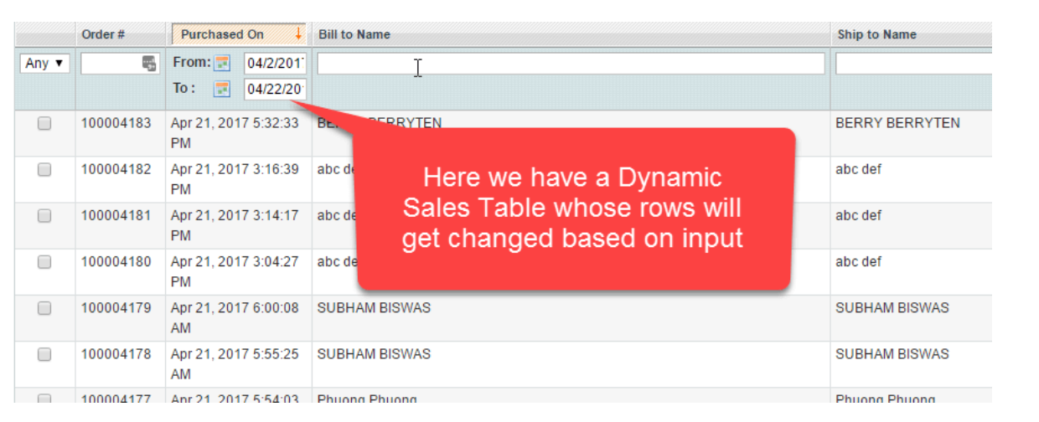

**package** Interview_Practice;

**import** java.util.List;

**import** org.openqa.selenium.By;

**import** org.openqa.selenium.JavascriptExecutor;

**import** org.openqa.selenium.WebDriver;

**import** org.openqa.selenium.WebElement;

**import** org.openqa.selenium.chrome.ChromeDriver;

**import** io.github.bonigarcia.wdm.WebDriverManager;

**public** **class** WebTables {

**public** **static** **void** main(String[] args) {

WebDriverManager.*chromedriver*().setup();

WebDriver driver = **new** ChromeDriver();

driver.manage().window().maximize();

driver.get("https://testautomationpractice.blogspot.com/");

JavascriptExecutor js = (JavascriptExecutor) driver;

js.executeScript("window.scrollBy(0,1400)", "");

//Find the rows in Web Tables

List<WebElement>rows = driver.findElements(By.*xpath*("//table[@name = 'BookTable']/tbody/tr"));

System.***out***.println("Rows:"+rows.size());

//Find the total columns in Web Tables

List<WebElement>columns = driver.findElements(By.*xpath*("//table[@name = 'BookTable']/tbody/tr[2]/td"));

System.***out***.println("columns:"+columns.size());

**for**(**int** r=2; r<=rows.size();r++) //row

{

**for**(**int** c=1;c<=columns.size();c++) //column

{

String data = driver.findElement(By.*xpath*("//table[@name = 'BookTable']/tbody/tr[" + r +"]/td[" + c + "]")).getText();

System.***out***.println(data);

}

}

}

}